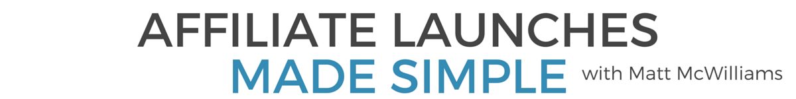
Affiliate Opportunity: Chandler Bolt's Self-Publishing School
How does a "nobody" with average grades in English publish multiple bestselling books? By following a system. That system is Chandler Bolt's Self-Publishing School, which teaches the methods that Chandler himself has used to publish bestsellers despite being a C-student in English. And it's a great affiliate opportunity.
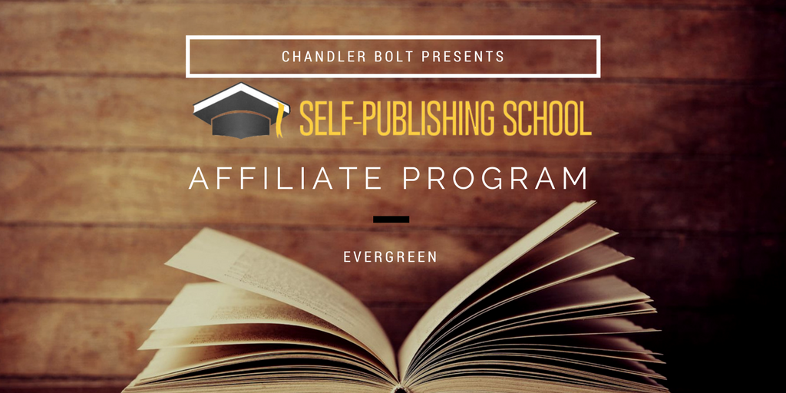
I'm excited about Chandler's launch for 4 reasons:
- The course is solid. I never recommend promoting anything you don't believe in wholeheartedly. And this is something I believe in 100%. I've been through the course (and...hint, hint, will be using it soon for my upcoming book!) and it is one of the best organized, in-depth courses in all of internet marketing.
- It has proven results. A lot of times what worked for the teacher doesn't work for the students, usually because the course creator sucks as a teacher or the course doesn't teach enough. That is the not the case with SPS. The course has produced dozens of bestselling authors across almost every imaginable niche, many of whom had never published more than a few blog posts.
- The launch PLC is phenomenal. Good pre-launch content in a launch toes the line between giving away enough to whet the audience's appetite and giving away too much. I've found that the most successful people aren't afraid to give away too much. Chandler's PLC is the type you can be proud to promote, because even if your tribe never buys a thing, they will learn a ton.
- Chandler. I first met Chandler nearly three years ago through a mutual friend. I've been blessed over the past few years to spend a lot of time with him and now to call him a friend. He even got Tara and I backstage to see our favorite band, NEEDTOBREATHE (his brother is Seth Bolt, the bassist). So yeah, he's pretty much awesome. :)
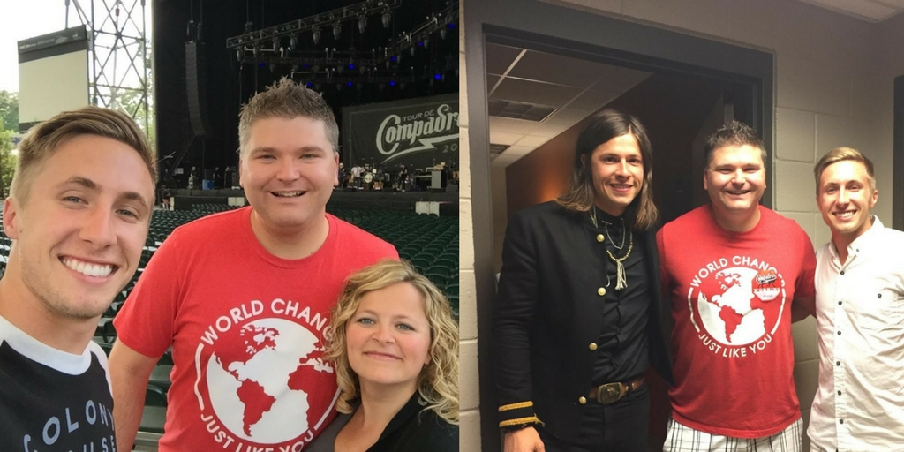
My wife Tara and me backstage with Chandler and Seth Bolt

About the Course
81% of Americans say they want to write a book. Less than 1% do.
Let that sink in for a minute...
We're not talking about doing something outlandish like becoming an astronaut or a professional athlete. We're talking about something that anyone is capable of doing.
And yet...99 out 100 people who say they want to do it don't actually do it. That is ridiculous.
Enter Self-Publishing School.
SPS is the go-to course for anyone looking to publish a book, without all the hassle of working with a traditional publisher.
The reality is that for the majority of prospective authors, finding a publisher and working with them is a barrier, not a help. It's usually not worth the effort. It often ends up being more expensive with no upside in results.
That's why SPS is so powerful. It eliminates barriers and helps you get published.
One of the cool ways they do that is with this contract from day one:
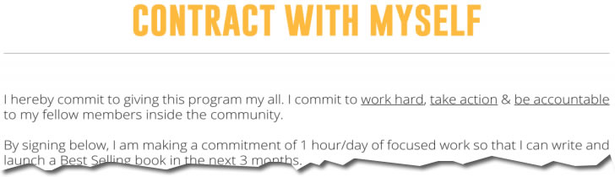
The course is insanely detailed, walking an aspiring author from nothing written to published author. It shows students how to write and finish their book, then shows them how to market and sell their books.
Many students have gone on to be bestselling authors (though, I should point out this is certainly not a promise).

Target Audience
SPS is for that 80% who say they want to write a book but never do. That's a pretty large audience, but it's true.
Chandler's course has students who've written books about:
- online marketing
- religion
- finances
- productivity
- health and fitness
- music
- travel
- memoirs
- sports
- career advancement
- dating and relationships
- ...and so many more topics
It literally can be used by anyone.

What's Inside the Course?
The course is broken into six phases, plus a phase on self-published hard copy books and audiobooks, the bonuses, and resources.
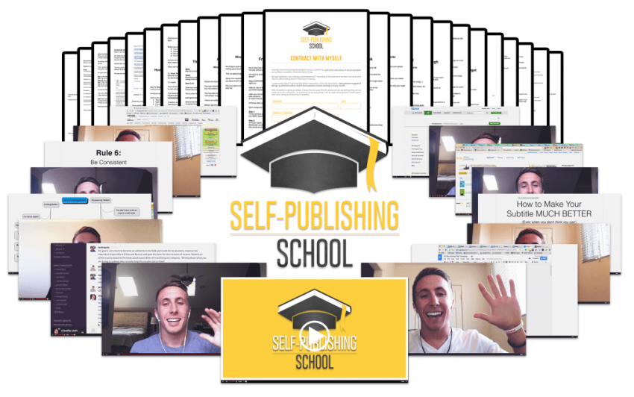
Phase 1: Positioning and Outlining
Most people in the Self Publishing School community don’t have a clue where to start. Phase 1 helps them get clarity on their WHY – their purpose for writing the book. And it will show them how to position the book to get the most sales.
The question many people ask before buying is: Will Self-Publishing School help me if I don’t even know what I want to write about?
Yep. Chandler covers that, too.
Phase 2: Rapid Writing
AKA – How to write your book fast.
Part 9 of this phase is particularly useful if you’ve ever suffered from writer’s block (and who hasn't?).
Phase 3: Editing Made Easy
In this phase, Chandler shows you how to outsource this boring part of the process (at least most of it) without costing a fortune.

Phase 4: Pain-free Publishing
The book is ready…now what?
This is where most first-time authors get stuck. This is the heart of the secret sauce in Self-Publishing School. If the course started here, honestly it would still be worth more than the asking price. They cover all the bases here.
Some of the things Chandler covers here (there’s a lot more, but this gives you a taste):
- How to format for Kindle
- How to hire someone to format your book
- How to upload your book the right way
- The step-by-step guide to finishing and self-publishing your book
Phase 5: Launching Your Self-Published Book
Chandler literally shares his blueprint here. His proven blueprint.
Chandler and his team break it into three phases:
Building Buzz: 2-3 weeks
Pre-Launch Week: 1 week
Launch Week: 1 week
Chandler covers:
- The step-by-step method that he uses to launch #1 self-published books
- Social media marketing
- Kindle Consumer Psychology
- How to write an author bio
- How to reach out to influencers (networking)
- How to optimize your book listing
- How to get reviews early on
- And SOOOO much more here
Phase 6: Maintaining book sales
So you launched the book…now what?
This is all about keeping sales up long-term.

Commissions, Price Points and Prizes
Commission: 40% + 2nd tier commissions
Price Point: $997 and $1997 courses
I've promoted it in the past myself and it converted extremely well. Chandler has launched the course over 5 times, plus the ongoing evergreen funnel.
All of that to say, the sales funnel is absolutely solid.
Prizes: There are no prizes if you are promoting the evergreen funnel, but it is a killer source of ongoing, passive income for your site.
For the launches, Chandler always has amazing prizes. In a recent launch, the top optin prize was a 14 Day Alaskan Cruise (Balcony Suite) PLUS Airfare.
#totallyawesome
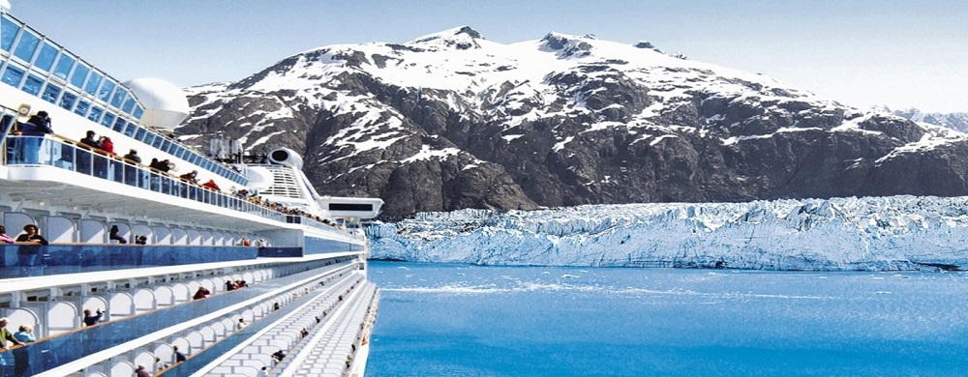
The top sales prize for a recent launch was a Smart Car. Right on down to all kinds of other prizes. You name it, you can win it!

Important Dates
Fall Launch: July 31-August 13
This program is also available evergreen.
Chandler also does two launches per year, so sign up now, add the offer to your automation sequences, sidebar ads and your resource page and then he'll let you know when the next one is coming up!
If you have anyone in your audience who wants to write a book, this launch is for you.

